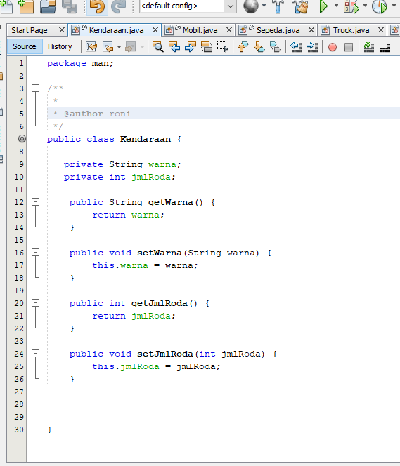

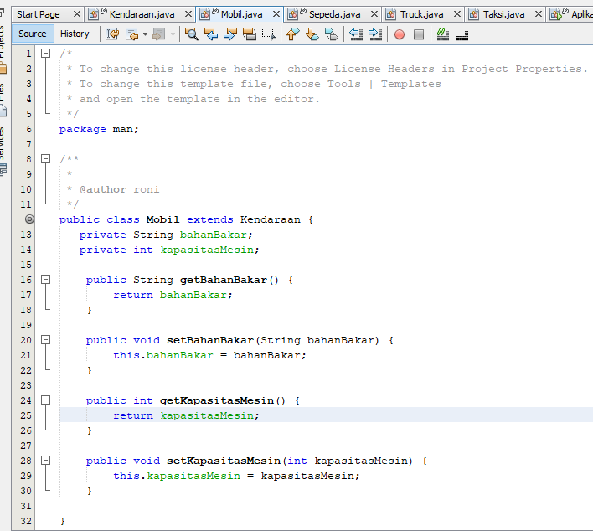

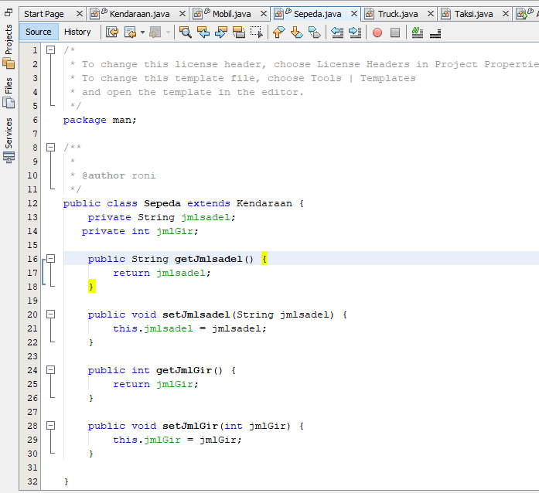

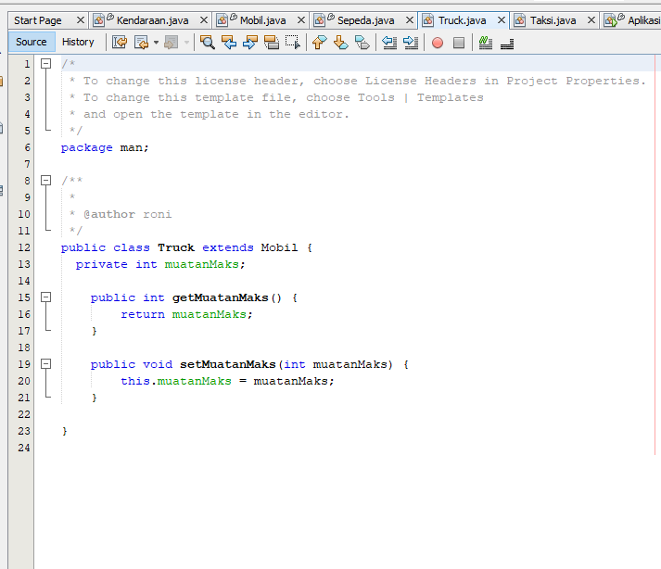

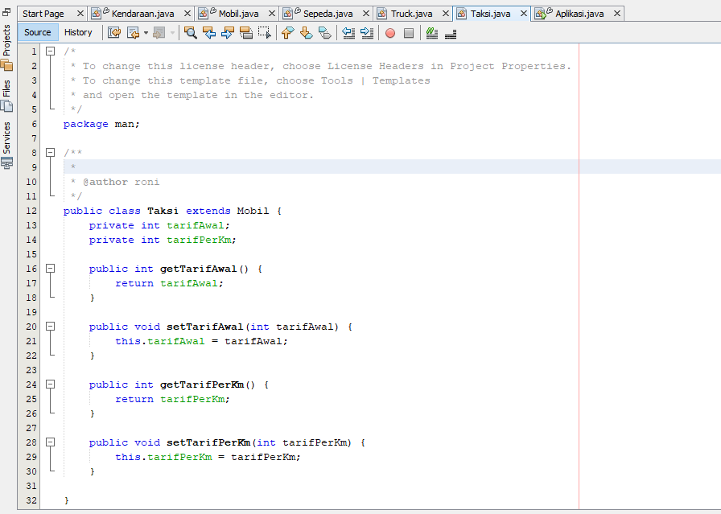

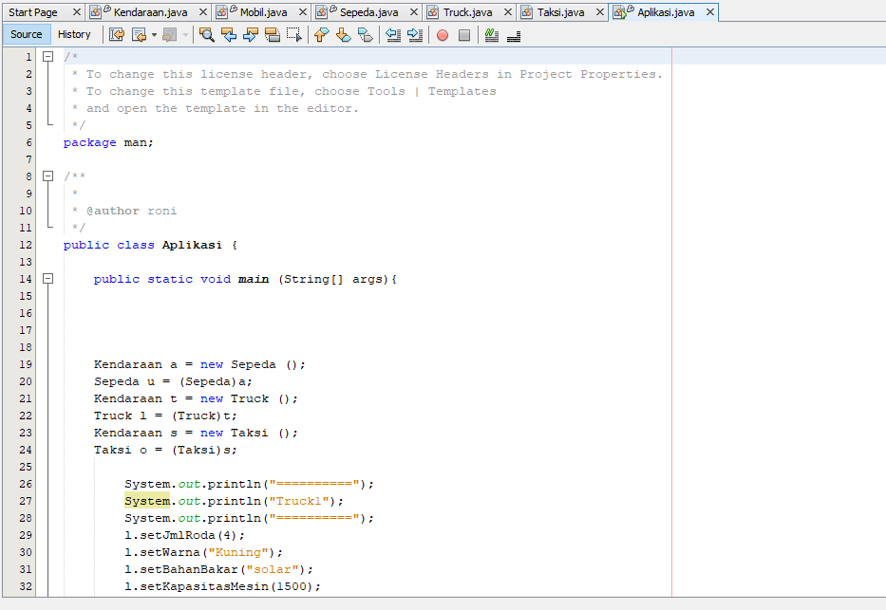

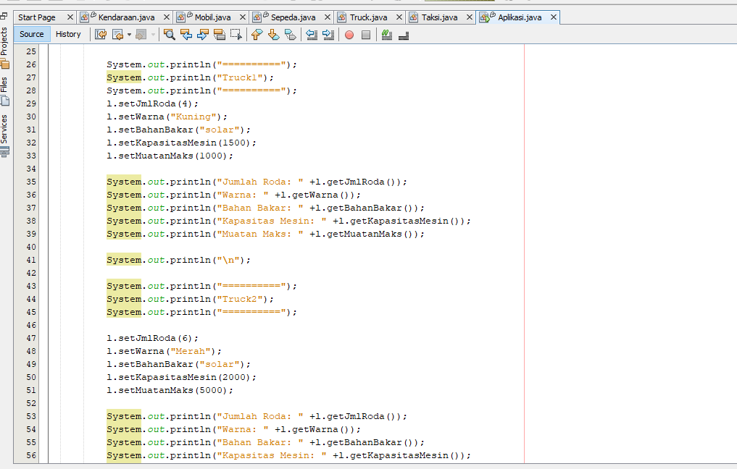

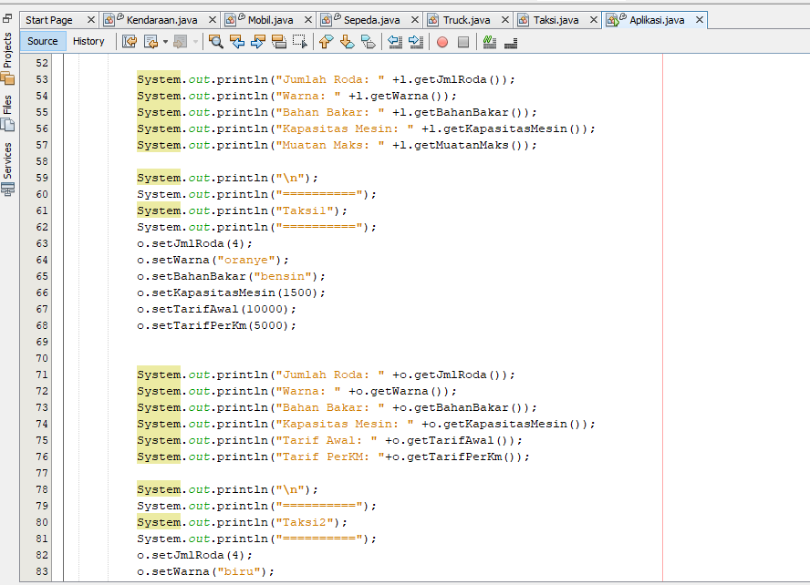

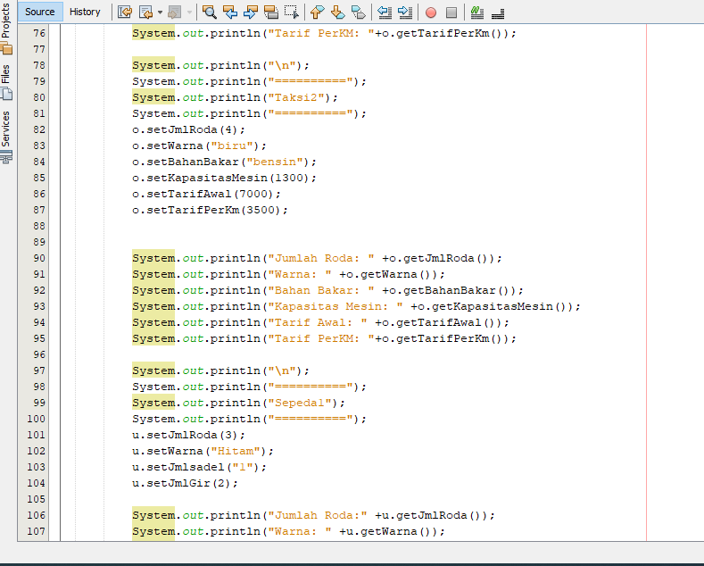

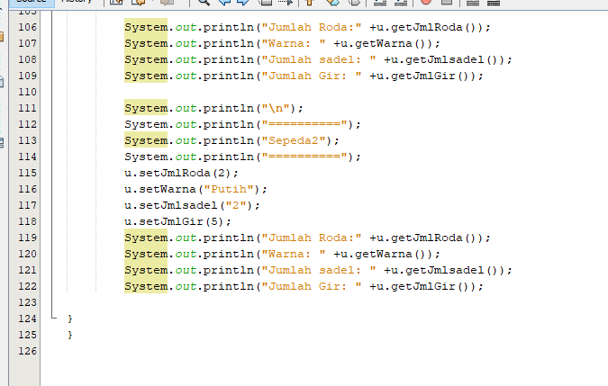

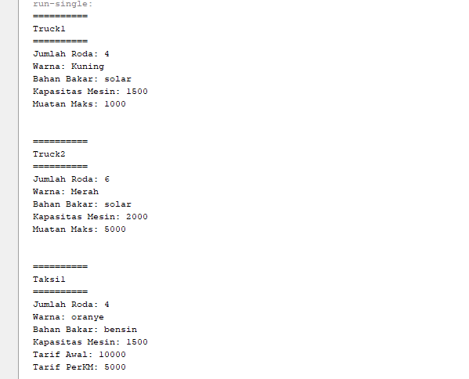

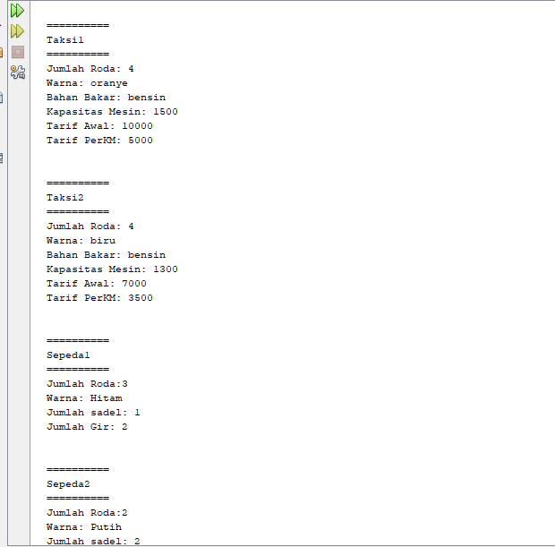

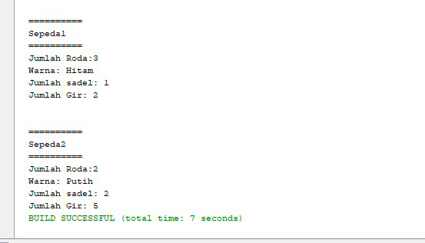

Kendaraan.java

package man;

/\*\*

\*

\* @author roni

\*/

public class Kendaraan {

private String warna;

private int jmlRoda;

public String getWarna() {

return warna;

}

public void setWarna(String warna) {

this.warna = warna;

}

public int getJmlRoda() {

return jmlRoda;

}

public void setJmlRoda(int jmlRoda) {

this.jmlRoda = jmlRoda;

}

}

Mobil.java

/\*

\* To change this license header, choose License Headers in Project Properties.

\* To change this template file, choose Tools | Templates

\* and open the template in the editor.

\*/

package man;

/\*\*

\*

\* @author roni

\*/

public class Mobil extends Kendaraan {

private String bahanBakar;

private int kapasitasMesin;

public String getBahanBakar() {

return bahanBakar;

}

public void setBahanBakar(String bahanBakar) {

this.bahanBakar = bahanBakar;

}

public int getKapasitasMesin() {

return kapasitasMesin;

}

public void setKapasitasMesin(int kapasitasMesin) {

this.kapasitasMesin = kapasitasMesin;

}

}

Sepeda.java

/\*

\* To change this license header, choose License Headers in Project Properties.

\* To change this template file, choose Tools | Templates

\* and open the template in the editor.

\*/

package man;

/\*\*

\*

\* @author roni

\*/

public class Sepeda extends Kendaraan {

private String jmlsadel;

private int jmlGir;

public String getJmlsadel() {

return jmlsadel;

}

public void setJmlsadel(String jmlsadel) {

this.jmlsadel = jmlsadel;

}

public int getJmlGir() {

return jmlGir;

}

public void setJmlGir(int jmlGir) {

this.jmlGir = jmlGir;

}

}

Truck.java

/\*

\* To change this license header, choose License Headers in Project Properties.

\* To change this template file, choose Tools | Templates

\* and open the template in the editor.

\*/

package man;

/\*\*

\*

\* @author roni

\*/

public class Truck extends Mobil {

private int muatanMaks;

public int getMuatanMaks() {

return muatanMaks;

}

public void setMuatanMaks(int muatanMaks) {

this.muatanMaks = muatanMaks;

}

}

Taksi.java

/\*

\* To change this license header, choose License Headers in Project Properties.

\* To change this template file, choose Tools | Templates

\* and open the template in the editor.

\*/

package man;

/\*\*

\*

\* @author roni

\*/

public class Taksi extends Mobil {

private int tarifAwal;

private int tarifPerKm;

public int getTarifAwal() {

return tarifAwal;

}

public void setTarifAwal(int tarifAwal) {

this.tarifAwal = tarifAwal;

}

public int getTarifPerKm() {

return tarifPerKm;

}

public void setTarifPerKm(int tarifPerKm) {

this.tarifPerKm = tarifPerKm;

}

}

Aplikasi.java

/\*

\* To change this license header, choose License Headers in Project Properties.

\* To change this template file, choose Tools | Templates

\* and open the template in the editor.

\*

package man;

/\*\*

\*

\* @author roni

\*/

public class Aplikasi {

public static void main (String[] args){

Kendaraan a = new Sepeda ();

Sepeda u = (Sepeda)a;

Kendaraan t = new Truck ();

Truck l = (Truck)t;

Kendaraan s = new Taksi ();

Taksi o = (Taksi)s;

System.out.println("Truck1");

l.setJmlRoda(4);

l.setWarna("Kuning");

l.setBahanBakar("solar");

l.setKapasitasMesin(1500);

l.setMuatanMaks(1000);

System.out.println("Jumlah Roda: " +l.getJmlRoda());

System.out.println("Warna: " +l.getWarna());

System.out.println("Bahan Bakar: " +l.getBahanBakar());

System.out.println("Kapasitas Mesin: " +l.getKapasitasMesin());

System.out.println("Muatan Maks: " +l.getMuatanMaks());

System.out.println("\n");

System.out.println("Truck2");

l.setJmlRoda(6);

l.setWarna("Merah");

l.setBahanBakar("solar");

l.setKapasitasMesin(2000);

l.setMuatanMaks(5000);

System.out.println("Jumlah Roda: " +l.getJmlRoda());

System.out.println("Warna: " +l.getWarna());

System.out.println("Bahan Bakar: " +l.getBahanBakar());

System.out.println("Kapasitas Mesin: " +l.getKapasitasMesin());

System.out.println("Muatan Maks: " +l.getMuatanMaks());

System.out.println("\n");

System.out.println("==========");

System.out.println("Taksi1");

System.out.println("==========");

o.setJmlRoda(4);

o.setWarna("oranye");

o.setBahanBakar("bensin");

o.setKapasitasMesin(1500);

o.setTarifAwal(10000);

o.setTarifPerKm(5000);

System.out.println("Jumlah Roda: " +o.getJmlRoda());

System.out.println("Warna: " +o.getWarna());

System.out.println("Bahan Bakar: " +o.getBahanBakar());

System.out.println("Kapasitas Mesin: " +o.getKapasitasMesin());

System.out.println("Tarif Awal: " +o.getTarifAwal());

System.out.println("Tarif PerKM: "+o.getTarifPerKm());

System.out.println("\n");

System.out.println("Taksi2");

o.setJmlRoda(4);

o.setWarna("biru");

o.setBahanBakar("bensin");

o.setKapasitasMesin(1300);

o.setTarifAwal(7000);

o.setTarifPerKm(3500);

System.out.println("Jumlah Roda: " +o.getJmlRoda());

System.out.println("Warna: " +o.getWarna());

System.out.println("Bahan Bakar: " +o.getBahanBakar());

System.out.println("Kapasitas Mesin: " +o.getKapasitasMesin());

System.out.println("Tarif Awal: " +o.getTarifAwal());

System.out.println("Tarif PerKM: "+o.getTarifPerKm());

System.out.println("\n");

System.out.println("Sepeda1");

u.setJmlRoda(3);

u.setWarna("Hitam");

u.setJmlsadel("1");

u.setJmlGir(2);

System.out.println("Jumlah Roda:" +u.getJmlRoda());

System.out.println("Warna: " +u.getWarna());

System.out.println("Jumlah sadel: " +u.getJmlsadel());

System.out.println("Jumlah Gir: " +u.getJmlGir());

System.out.println("\n");

System.out.println("Sepeda2");

u.setJmlRoda(2);

u.setWarna("Putih");

u.setJmlsadel("2");

u.setJmlGir(5);

System.out.println("Jumlah Roda:" +u.getJmlRoda());

System.out.println("Warna: " +u.getWarna());

System.out.println("Jumlah sadel: " +u.getJmlsadel());

System.out.println("Jumlah Gir: " +u.getJmlGir());

}

}

OUTPUT

==========

Truck1

==========

Jumlah Roda: 4

Warna: Kuning

Bahan Bakar: solar

Kapasitas Mesin: 1500

Muatan Maks: 1000

==========

Truck2

==========

Jumlah Roda: 6

Warna: Merah

Bahan Bakar: solar

Kapasitas Mesin: 2000

Muatan Maks: 5000

==========

Taksi1

==========

Jumlah Roda: 4

Warna: oranye

Bahan Bakar: bensin

Kapasitas Mesin: 1500

Tarif Awal: 10000

Tarif PerKM: 5000

==========

Taksi2

==========

Jumlah Roda: 4

Warna: biru

Bahan Bakar: bensin

Kapasitas Mesin: 1300

Tarif Awal: 7000

Tarif PerKM: 3500

==========

Sepeda1

==========

Jumlah Roda:3

Warna: Hitam

Jumlah sadel: 1

Jumlah Gir: 2

==========

Sepeda2

==========

Jumlah Roda:2

Warna: Putih

Jumlah sadel: 2

Jumlah Gir: 5

BUILD SUCCESSFUL (total time: 3 seconds)